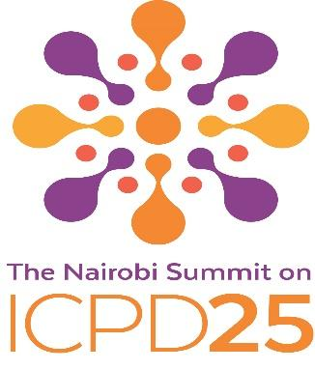
High Level Briefing Lunch on ICPD25 and Nairobi High Level Summit on ICPD
69th session of the WHO Regional Committee for Europe
Copenhagen, September 19, 2019
Concept Note

This year, 2019, marks the 25th anniversary of the Cairo International Conference on Population and Development, commonly known as the ICPD. The ICPD Programme of Action, endorsed by 179 Members States, marked a turning point by putting people’s rights and dignity at the very heart of sustainable development. It emphasized that sexual and reproductive health is a fundamental human right and that empowering women and girls is one of the most reliable pathways to improved well-being for all. Over the past 25 years, the progress in some of the key sexual and reproductive health indicators has been remarkable, particularly in the European region. The WHO Europe Action Plan for Sexual and Reproductive Health: towards achieving the 2030 Agenda for Sustainable Development in Europe – leaving no one behind is helping to accelerate progress. Despite gains made universal access to sexual and reproductive health remains yet a promise to be delivered to millions of women and girls, men and boys in the European region. Achieving the unfinished business of the ICPD agenda is essential for reaching the ambitious SDGs by 2030.

From 12-14 November, 2019, the governments of Kenya and Denmark and UNFPA are co-convening the Nairobi Summit on ICPD25, Accelerating the Promise a high-level conference to mobilize the political will and financial commitments we urgently need to finally and fully implement the ICPD Programme of Action. These commitments will be centred around achieving zero unmet need for family planning information and services, zero preventable maternal deaths, and zero sexual and gender-based violence and harmful practices against women and girls.

The Governments of Denmark and France, together with WHO and UNFPA are organizing a High Level Briefing- Lunch on September 19, 2019 to share the information on Nairobi Summit, to mobilize commitments to accelerate the implementation of the ICPD Programme of Action and join the efforts to advance the progress in European Action Plan for Sexual and Reproductive Health as a regional framework for delivering Cairo agenda in the region.

The governments of Republic of France, North Macedonia and Georgia are invited to co-host the briefing and speak to advances in their own countries. The financial and logistical support will be provided by UNFPA/EECARO and WHO/Europe.

Proposed agenda: ALL TBC
- Welcoming remarks - HRH the Crown Princess of Denmark and Patron of WHO Euro and UNFPA, representatives of the Government of Denmark, WHO and UNFPA.
- Accelerating ICPD in WHO Euro region - Ministers of Health of the Republic of North Macedonia, France, Tajikistan and Georgia
- Interactive dialogue and statements by WHO MS on implementation of commitments for Nairobi Summit Closing and next steps – WHO and UNFPA

